Understanding Large Networks: Engineered and Natural
Fall 2014

18-859E – Special Topics in Communications:
Information Flow in Networks: Communication, Computation, and Neuronal

12 units
Mon – Wed 4:30 pm – 5:50 pm
Recitation: Fri 2:30 pm – 3:50 pm
Instructor: Pulkit Grover, Assistant Professor
pulkit@cmu.edu

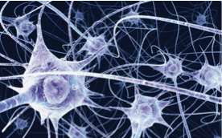

The joy of networks!

Why are networks so intriguing? The intrigue lies in how dumb components come together to do extremely smart things. It all lies in the network structure and dynamics. This course will bring together the understanding of networks – their structure and information flow dynamics – across fields of communication, computation, and neuroscience. Foundational topics that will be discussed include: efficient (in energy/time/resources) communication and computation through “good” network structures, notions of criticality in networks, key topics in network science and network analysis, etc. Applications of these concepts to neuronal networks will be discussed, including the efficient coding hypothesis in neuroscience, diseases of brain networks, criticality in neuronal networks, network analyses applied to the brain, etc.

Both foundational and application topics will be explored deeper through course projects. The goal is to equip students with the language and the big questions in these fields, as well as with tools to explore these questions. This is timely in view of the immense amounts of data being generated by biological and social networks. Keep an eye out for the open “office hour” in the first week to learn more about the course and ask questions!

Pre-reqs: Undergraduate probability, linear algebra, graduate standing.

